DAE 8ed, Problem 2.4

Given:

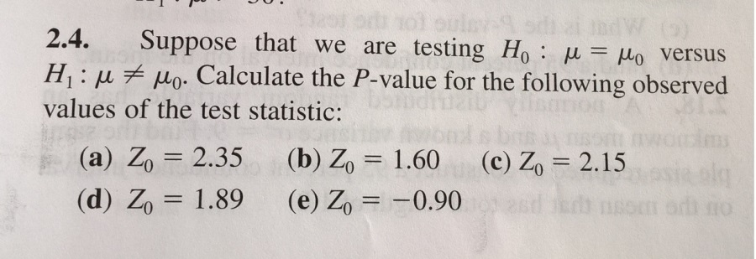

Solution:

The Z statistic is from a standard normal distribution N(µ,sigma), where µ=0 and sigma=1. The test is double sided as both values greater or smaller are possible under H1. The P-value is the probability for more extreme cases than Z0 (see figure 01).

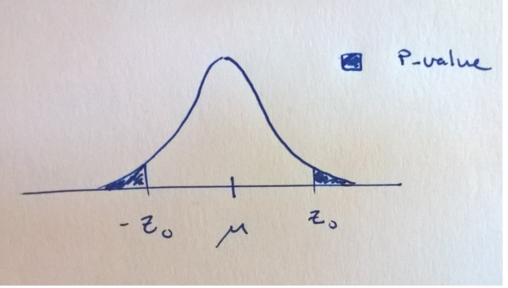

The distribution is symmetric around the mean (µ=0), with unit variance (sigma=1) and the P-value can therefore be described as twice the probability of more extreme cases than Z0, P(z>Z0), i.e.

P=2\*P(z>Z0)

This probability in turn is derived from the CDF as

P(z>Z0)=1-P(z≤Z0)=1-CDF(Z0)

The CDF of the normal distribution is determined by the error function, which does not have an analytical solution for the 1-D case. Using MATLAB/OCTAVE the following code will determine the P-values.

Z0=[2.35, 1.60, 2.15, 1.89, -0.90]'; %Vector cases A-E

P=2\*(1-normcdf(abs(Z0),0,1)) %Note the absolute value due to case e being negative

P =

0.0188

0.1096

0.0316

0.0588

0.3681

Here the smaller values are more likely under H1.